Earthbound Fresh Veggies
Mixed Baby Greens
A delicious blend of mild and bold baby greens. Mixed Baby Greens
Organic baby lettuces (red and green romaine, red and green oak leaf, lollo rosa, tango), organic red and green chard, organic mizuna, organic arugula, organic frisée, organic radicchio. (The ingredients in each package may vary.)
• 5 oz clamshell
• 4 oz bag
Baby Arugula
Tender young leaves, perfect flavor accents in salads and recipes.
• 5 oz clamshell
• 5 oz bag
Baby Spinach
Tender young leaves perfect for salads and recipes.
• 5 oz clamshell
• 5 oz bag
Fresh Herb Salad
To our basic Mixed Baby Greens blend, we add fresh parsley, dill, and cilantro for a burst of herbal flavors. Organic baby lettuces (red and green romaine, red and green oak leaf, lollo rosa, tango), organic red and green chard, organic mizuna, organic arugula, organic frisée, organic radicchio, organic parsley, organic dill, organic cilantro. (The ingredients in each package may vary.)
• 5 oz clamshell
• 11 oz clamshell
• 1 lb clamshell
• 4 oz bag
Baby Romaine
Organic red and green baby romaine leaves.
• 5 oz clamshell
• 11 oz clamshell
• 1 lb clamshell
• 5 oz bag

Baby Lettuces
A blend of milder baby lettuces. Organic baby lettuces (red and green oak leaf, lollo rosa, red and green romaine, tango).
• 5 oz clamshell
• 5 oz bag
Mixed Baby Greens
Salad Kit
Enjoy a perfect individual salad to go: fresh organic greens, delicious organic dressing, crunchy walnuts, and a fork — use the clamshell package as a bowl.

Caesar Salad Kit
Enjoy a perfect individual organic salad to go: fresh romaine, delicious caesar dressing, crunchy croutons, and a fork — use the clamshell package as a bowl.
Baby Spinach Salad Kit
Enjoy a perfect individual organic salad to go: fresh baby spinach, tangy sesame-soy dressing, crunchy peanuts, and a fork — use the clamshell package as a bowl.

Carrots with Tops (Bunched Carrots)
Flavorful organic carrots are high in vitamins A, C, and K, plus fiber and the antioxidants beta carotene and lutein. Available year-round in bunches or cello packs.

Baby Carrots
These baby carrots are perfect for healthy snacks, lunches, even for saving kitchen prep time.

Baby Carrot Dippers
Crunchy organic mini carrots and creamy ranch dip are combined in perfect proportions for convenient, healthy snacks. Available in packs of three.

Carrot Snack Packs
These smaller portions of crunchy organic mini carrots are a convenient way to add taste and nutrition to lunch bags — an easy snack option, too.

Beets
Colorful beets are delicious cooked or raw, hot or cold, and they’re high in vitamin C, folate, fiber, and antioxidants. Beets may be used in these easy to prepare dishes such as Apple, Beet, and Stilton Salad, Baby Greens with Beets and Tarragon Vinaigrette, Beet and Arugula Salad with Walnuts and Feta Cheese, Grilled Shrimp Salad with Beet Vinaigrette and Watercress Salad with Roasted Beets and Oranges.

Cauliflower
Low in calories, cauliflower is delicious cooked or raw, and it's an excellent source of vitamin C and dietary fiber. These are individually wrapped. These are several eay to prepare cauliflower dishes such as Cauliflower and Broccoli Cheesy Bake, Curried Vegetables and Tofu, Grilled Shrimp with Cauliflower , Marinated Cauliflower Salad and Roasted Cauliflower and Garlic Soup.

Broccoli
Versatile broccoli is delicious raw or cooked, and it’s packed with so many complex nutrients that it’s often called a “superfood.” Broccoli is an excellent source of vitamins A, C, and K, as well as folate and fiber.

Red Onions
Yellow Onions
Bulb onions can be used in almost every type of food, and they’re a very good source of vitamin C, dietary fiber, and antioxidants. Red and yellow onions are available in 3-pound mesh bags year-round.

Garlic
In addition to its signature flavor and aroma, garlic is known for a wide range of beneficial health effects. Available in 3-ounce mesh bags.

White Pearl
Red Pearl
Boiler Onions
Perfect size and flavor for a wide variety of recipes. Available in 6-ounce mesh bags.

Iceberg Lettuce
Crunchy, mild iceberg is one of the most familiar ingredients in American salad bowls. Individual cello-wrapped heads are available year-round.

Red Potatoes
Red-skinned potatoes hold their shape well, making them ideal in salads and soups. Available seasonally in 3-pound poly bags.

Russet Potatoes
Russets bake exceptionally well, and their high starch content yields fluffy mashed potatoes and french fries. Available seasonally in 5-pound poly bags.

Yellow Potatoes
The buttery flavor of organic yellow potatoes adds a wonderful depth of flavor to most potato recipes. Available seasonally in 3-pound mesh bags.

Yams
These versatile sweet potatoes are excellent sources of vitamins and fiber. Available in mesh bags.

FRUITS

Lemons
Tangy lemons available as individual fruit or in 2-pound mesh bags.

Grapefruit
Juicy grapefruit available as individual fruit or in 4-pound mesh bags.

Avocados
Fresh avocados, 3 in a mesh bag. Nutrient-rich, high in fiber, and delicious in salsas, sandwiches, salads, and dressings. Available year round. Avocado can be used to prepare dishes such as Avocado Salsa, Fuyu, Pear, and Avocado Salad, Mango and Avocado Salsa, Shrimp and Arugula Salad with Grapefruit and Avocado and Spinach and Avocado Dressing.
Kiwifruit
Flavorful organic kiwis are available sold individually. Their sweet-tart taste is refreshing and exotic.

Dried Mangos
Delightfully sweet and chewy, a delicious and nutritious treat with no added sugar. Available year-round in reclosable 3-ounce bags.

Dried Cranberries
Sweet-tart and delicious in everything from simple snacks to elegant recipes. Available in reclosable 4-ounce bags.

Dried Plums
Moist and sweet, great in all kinds of recipes or delicious on their own. Available in reclosable 6-ounce bags.

Dates
Moist and delectable, their exotic sweetness is wonderful for cooking or snacking. Available in reclosable 6-ounce bags.

Thompson Seedless Raisins
A favorite chewy treat for all ages, perfect for snacking, cooking, or baking. Available in reclosable 6-ounce bags.

Thompson Seedless Raisins Mini Packs
Perfect for children’s snacks or school lunchboxes. Available in 14-count bags of 0.5-ounce mini packs.

Thompson Seedless Raisins Snack Boxes
Conveniently sized for lunchbags, briefcases, backpacks, or gym bags. Available in 6-packs of 1.5-ounce snack boxes.

Driscolls Raspberries
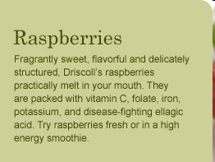
Raspberries are highly perishable, and also extremely fragile. However, a few simple, proper handling steps will ensure that your raspberries remain fresh and delicious. Under ideal conditions, raspberries should keep for 1-2 days in your refrigerator. For best results, Driscoll’s recommends that you keep your raspberries dry in storage and consume them as soon as possible after purchase. It’s also important to handle them gently when rinsing. Berries need to be rinsed just before use.
Driscolls Strawberries
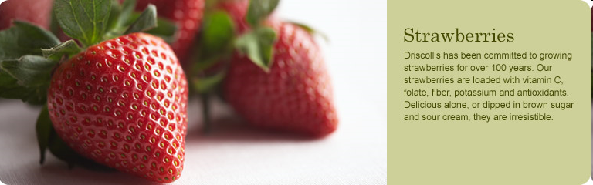
It’s important to treat your strawberries with TLC. Berries taste best when kept chilled. For best results, Driscoll’s recommends that you store your strawberries in their original container. Always refrigerate your berries immediately and don’t wash them until you are ready to use them. Gently rinse berries with the green caps still on, under cool water. After washing, remove the green caps. Allowing strawberries to reach room temperature before serving will enhance their natural flavors. Berries need to be rinsed just before use.

Driscolls Blackberries

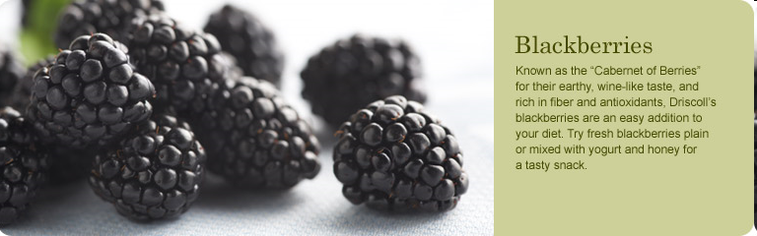
For best results, Driscoll’s recommends that you refrigerate your blackberries and keep them dry in storage. Blackberries, like their bush-berry cousin, the raspberry, are especially fragile. It is important to handle them gently when rinsing. If you plan to freeze your blackberries for jams and jellies, Driscoll’s recommends that you wash your berries carefully in cold water and pack them into freezable containers. Berries need to be rinsed just before use.

